PRACTICAL - 1
AIM : Implementation and Time analysis of sorting algorithms. Bubble sort, Selection sort, Insertion sort, Merge sort and Quicksort

BUBBLE SORT ALGORITHM
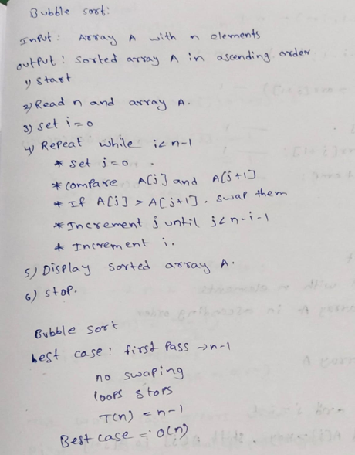
PROGRAM:

#include <iostream> using namespace std; class bubblesort
{ public:
int size, arr[100], i; void arrayinput()

{
cout << "Enter array size: ";
cin >> size;
cout << "Enter array elements:\n";
for (i = 0; i < size; i++)
{
cin >> arr[i];
}
}
void printarray()
{
for (i = 0; i < size; i++)
{
cout << arr[i] << " ";
}
cout << endl;
}
void bubblelogic()
{
int j, temp;
for (i = 0; i < size - 1; i++)
{
for (j = 0; j < size - i - 1; j++)
{
if (arr[j] > arr[j + 1])
{
temp = arr[j]; arr[j] = arr[j + 1]; arr[j + 1] = temp;
}
}
}
} }; int main() {
bubblesort bs; bs.arrayinput(); cout << "Before sorting: ";
bs.printarray(); bs.bubblelogic(); cout << "After sorting: "; bs.printarray(); return 0;
}

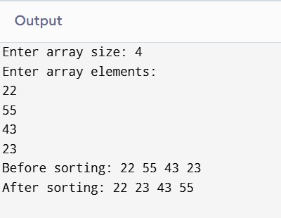
TIME COMPLEXITY : Step Count / Frequency Count Method ) best case : Array is already sorted; only one pass is needed
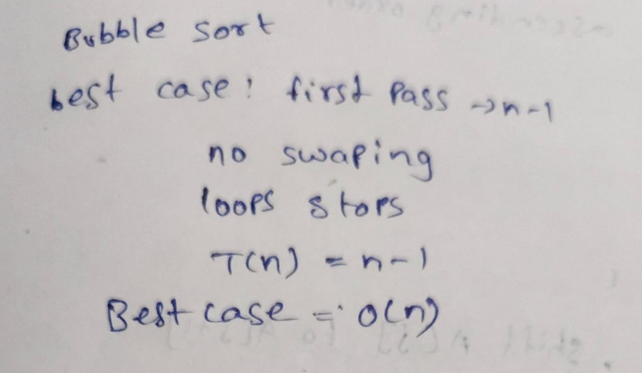

average case : Elements require multiple comparisons and swaps

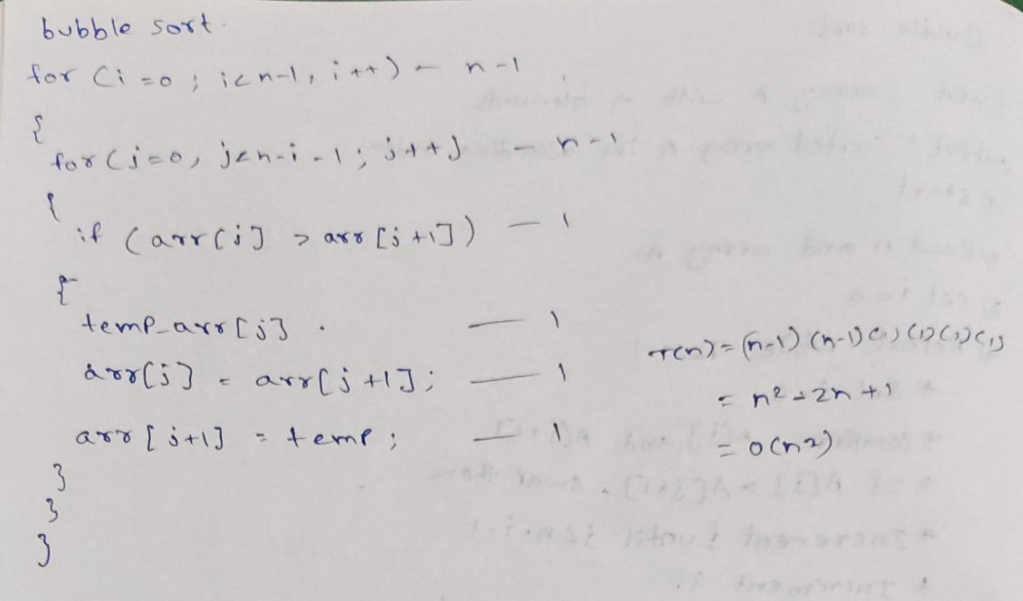

Worst case : Array is in reverse order; maximum comparisons and swaps

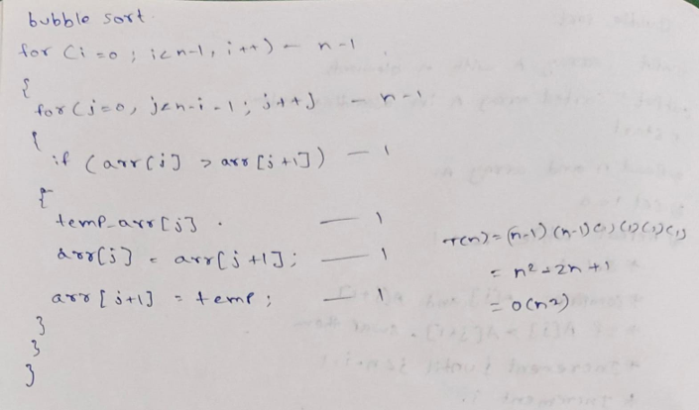

INSERTION ALGORITHM

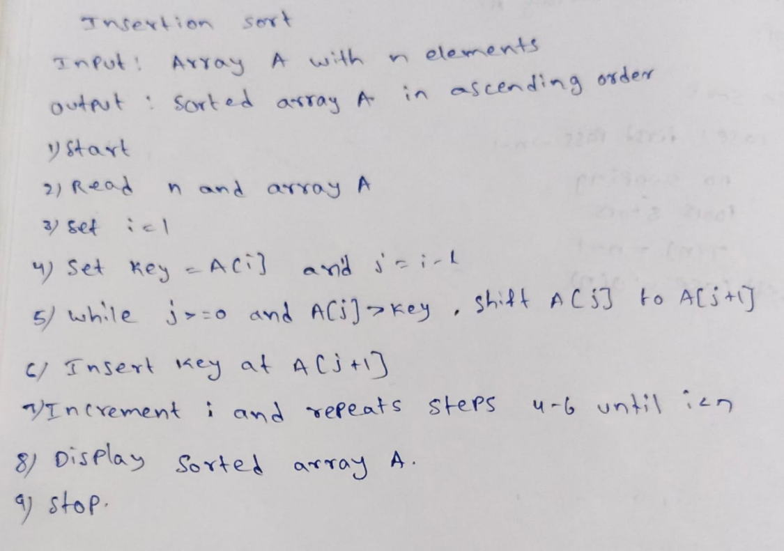

PROGRAM:

#include <iostream>
using namespace std;

class InsertionSort
{ public:
int size, arr[100], i, j, temp;

void arrayinput()
{
cout << "Enter array size: ";
cin >> size;

cout << "Enter array elements: "; for (i = 0; i < size; i++)

{
cin >> arr[i];
}
}

void printarray()
{
for (i = 0; i < size; i++)
{
cout << arr[i] << " ";
}
cout << endl;
}

void insertionsortlogic()
{
for (i = 1; i < size; i++)
{
temp = arr[i]; j = i - 1;

while (j >= 0 && arr[j] > temp)
{
arr[j + 1] = arr[j];
j--;
}

arr[j + 1] = temp;
}
} };

int main()
{
InsertionSort is;

is.arrayinput();

cout << "Before sorting: ";
is.printarray();

is.insertionsortlogic();

cout << "After sorting: ";
is.printarray();

return 0;
}
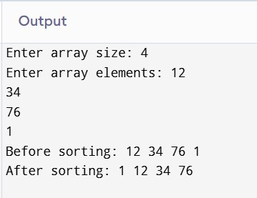

TIME COMPLEXITY : Step Count / Frequency Count Method ) best case : Array is already sorted; only one comparison per element

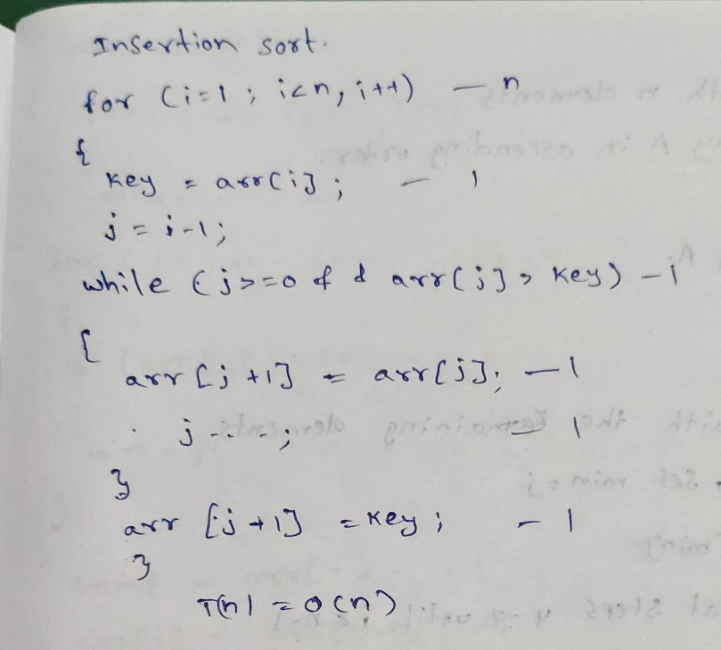

Average case : Elements are partially unordered, so shifting is required

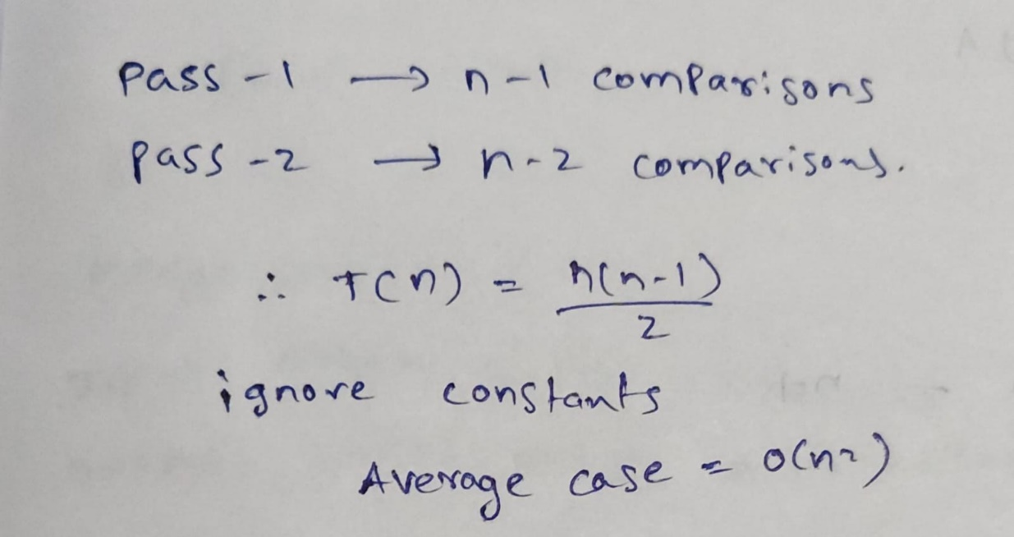

Worst case : Array is in reverse order; maximum shifting occurs

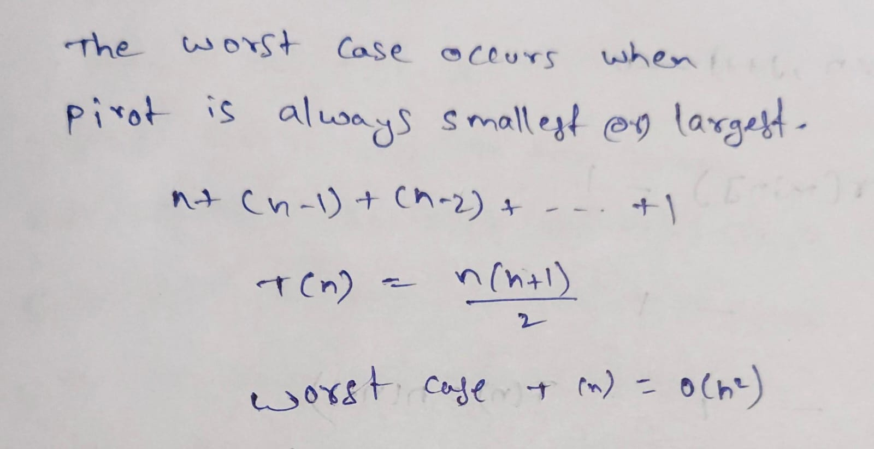

SELECTION SORT ALGORITHM
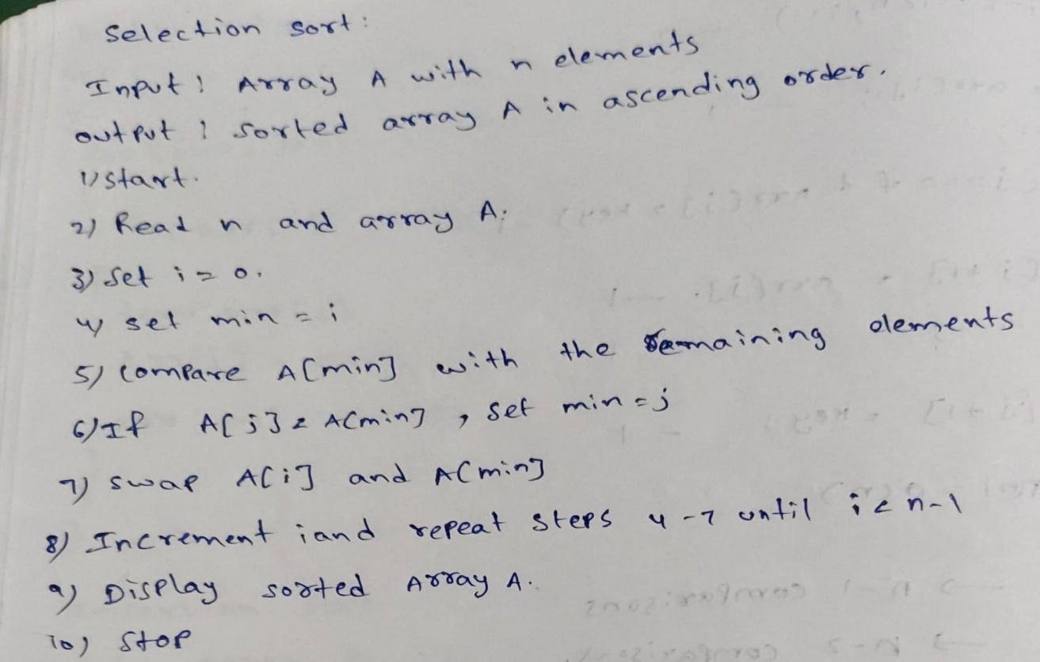
PROGRAM:

#include <iostream> using namespace std;

class SelectionSort
{ public:
int size, arr[100], i, j, temp;

void arrayinput()
{
cout << "Enter array size: ";
cin >> size;

cout << "Enter array elements: ";
for (i = 0; i < size; i++)
{
cin >> arr[i];
}
}

void printarray()
{
for (i = 0; i < size; i++)
{
cout << arr[i] << " ";
}
cout << endl;
}

void selectionsortlogic()
{
for (i = 0; i < size - 1; i++)
{
int min = i;

for (j = i + 1; j < size; j++)
{
if (arr[j] < arr[min])
{
min = j;
}
}

if (min != i)
{
temp = arr[i]; arr[i] = arr[min]; arr[min] = temp;
}
}
}
};

int main()
{
SelectionSort ss;

ss.arrayinput();

cout << "Before sorting: "; ss.printarray(); ss.selectionsortlogic();

cout << "After sorting: ";
ss.printarray();

return 0;
}

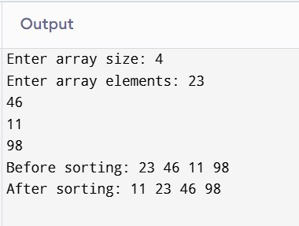
time complexity : Step Count / Frequency Count Method )
best case : Still compares all remaining elements to find the minimum

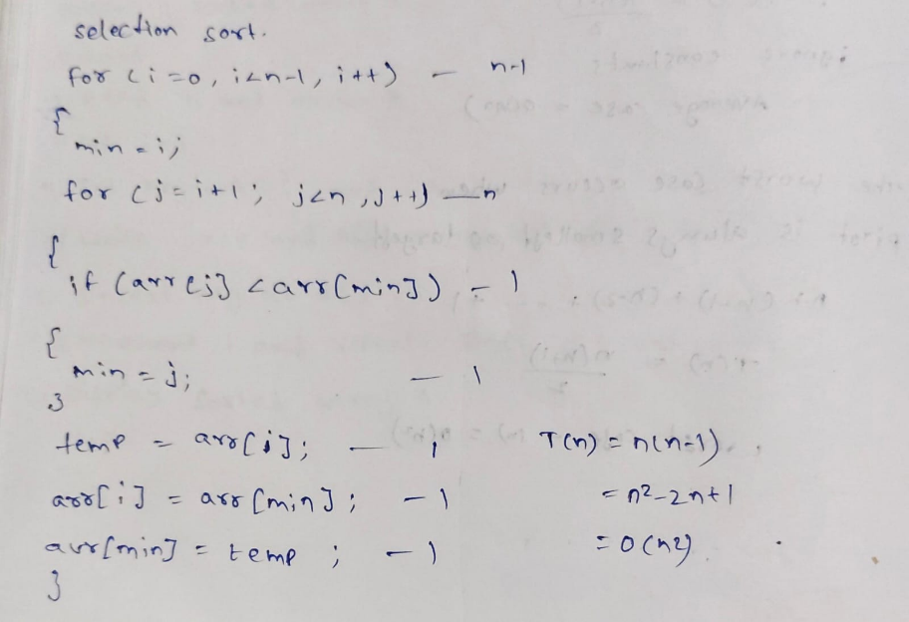

average case :
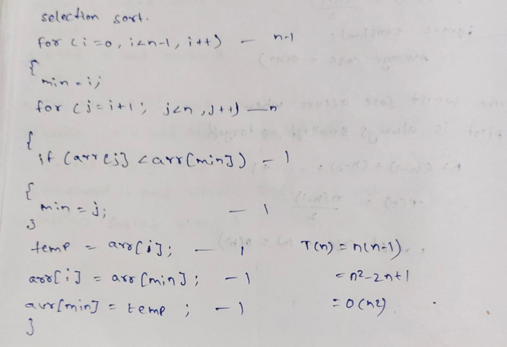

worst case :

MERGE SORT ALGORITHM :
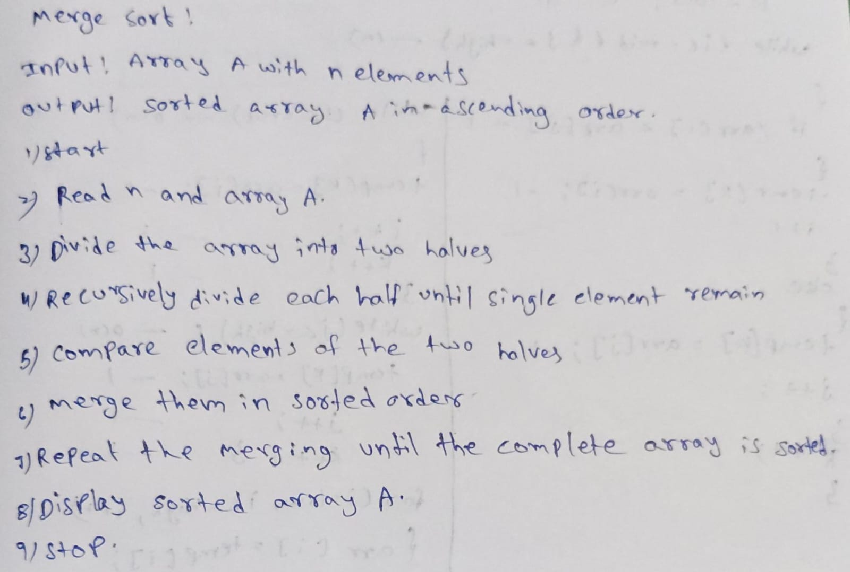
PROGRAM:

#include <iostream> using namespace std;

class mergesort
{ public:
int size, arr[100], i;

void arrayinput()
{
cout << "Enter array size: ";
cin >> size;

cout << "Enter array elements:\n";
for (i = 0; i < size; i++) {
cin >> arr[i];
}
}

void printarray()
{
for (i = 0; i < size; i++)
{
cout << arr[i] << " ";
}
cout << endl;
}

void merge(int low, int mid, int high)
{
int temp[100];
int i = low, j = mid + 1, k = low;

while (i <= mid && j <= high)
{
if (arr[i] <= arr[j])
{
temp[k] = arr[i];
i++; } else {
temp[k] = arr[j];
j++; } k++;
}

while (i <= mid)
{
temp[k] = arr[i];
i++; k++;
}

while (j <= high)
{
temp[k] = arr[j];
j++; k++;
}

for (i = low; i <= high; i++)
{
arr[i] = temp[i];
}
}

void mergelogic(int low, int high)
{
if (low < high)
{
int mid = (low + high) / 2;

mergelogic(low, mid); mergelogic(mid + 1, high);

merge(low, mid, high);
}
}
};

int main() {
mergesort ms;

ms.arrayinput();

cout << "Before sorting: "; ms.printarray();

ms.mergelogic(0, ms.size - 1);

cout << "After sorting: "; ms.printarray();

return 0;
}

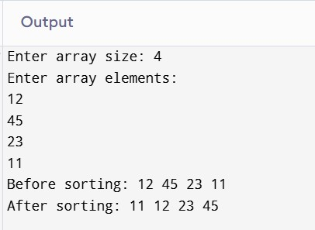
time complexity : Step Count / Frequency Count Method )
best case : Array is divided into log n levels and merging takes O(n)

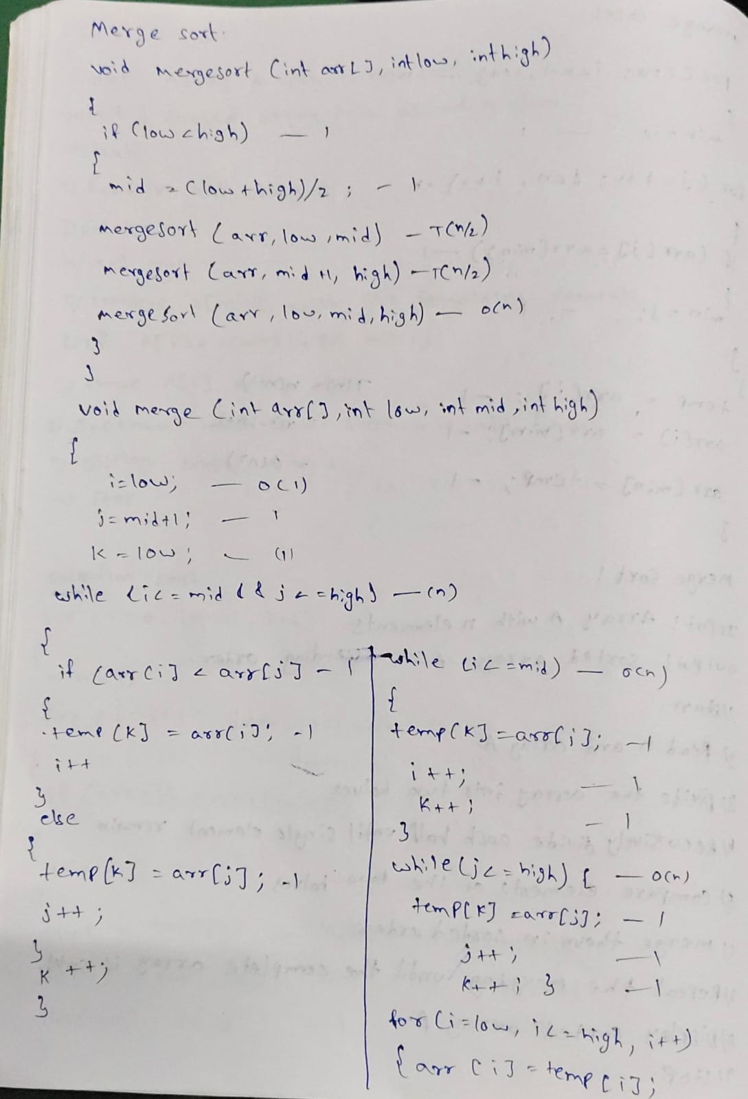

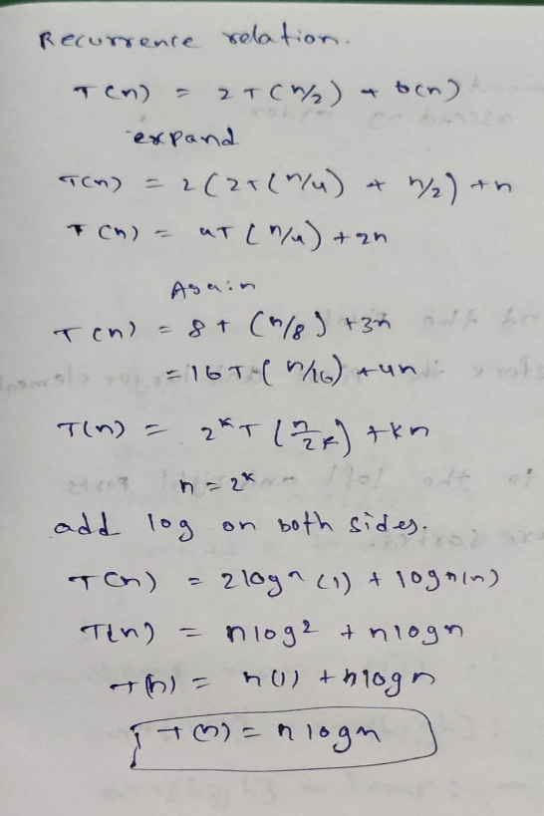

average case :

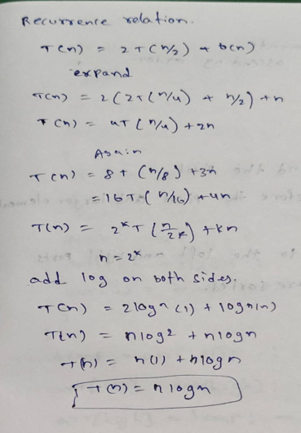

worst case :

QUICK SORT ALGORITHM:
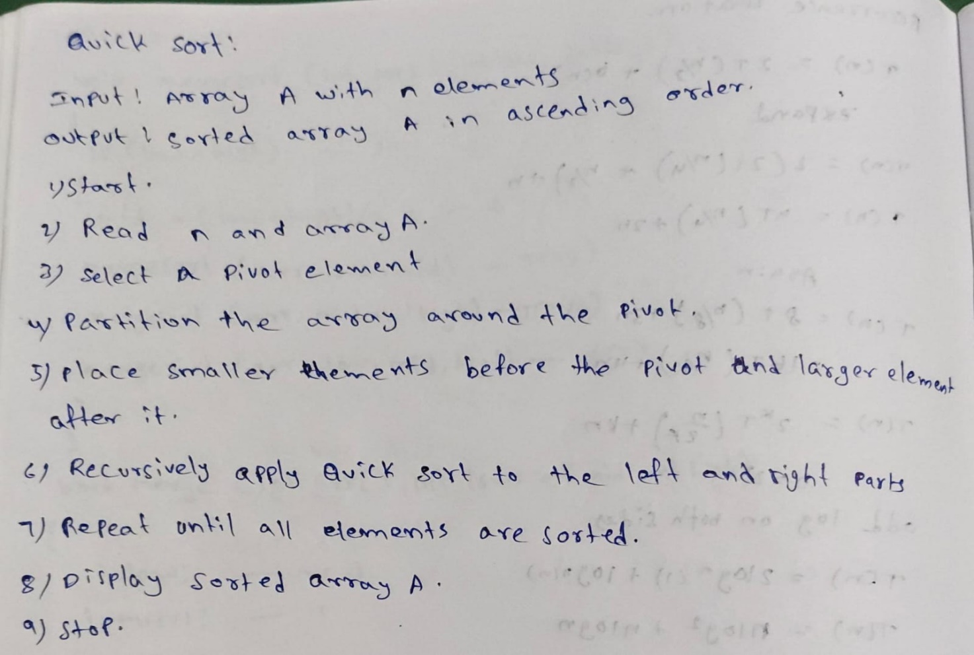
PROGRAM :
#include <iostream> #include <utility>
using namespace std;

class QuickSort
{ public:
int size, arr[100];

void arrayinput()
{
cout << "Enter array size: ";
cin >> size;

cout << "Enter array elements: ";
for (int i = 0; i < size; i++)
{
cin >> arr[i];
}
}

void printarray()
{
for (int i = 0; i < size; i++)
{
cout << arr[i] << " ";
}
cout << endl;
}

int partition(int lb, int ub)
{
int pivot = arr[lb]; int start = lb;
int end = ub;

while (start < end)
{
while (start <= ub && arr[start] <= pivot) start++;

while (arr[end] > pivot)
end--;

if (start < end)
swap(arr[start], arr[end]);
}

swap(arr[lb], arr[end]); return end;
}

void quicksortlogic(int lb, int ub)
{
if (lb < ub)
{
int loc = partition(lb, ub);
quicksortlogic(lb, loc - 1);
quicksortlogic(loc + 1, ub);
}
}

void sort()
{
quicksortlogic(0, size - 1);
}
};

int main()
{
QuickSort qs;

qs.arrayinput();

cout << "Before sorting: ";
qs.printarray();

qs.sort();

cout << "After sorting: "; qs.printarray();

return 0;
}
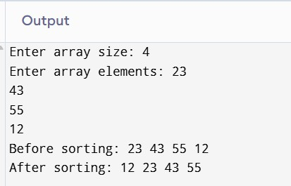

TIME COMPLEXITY : Step Count / Frequency Count Method ) best case : Pivot divides the array into nearly equal parts

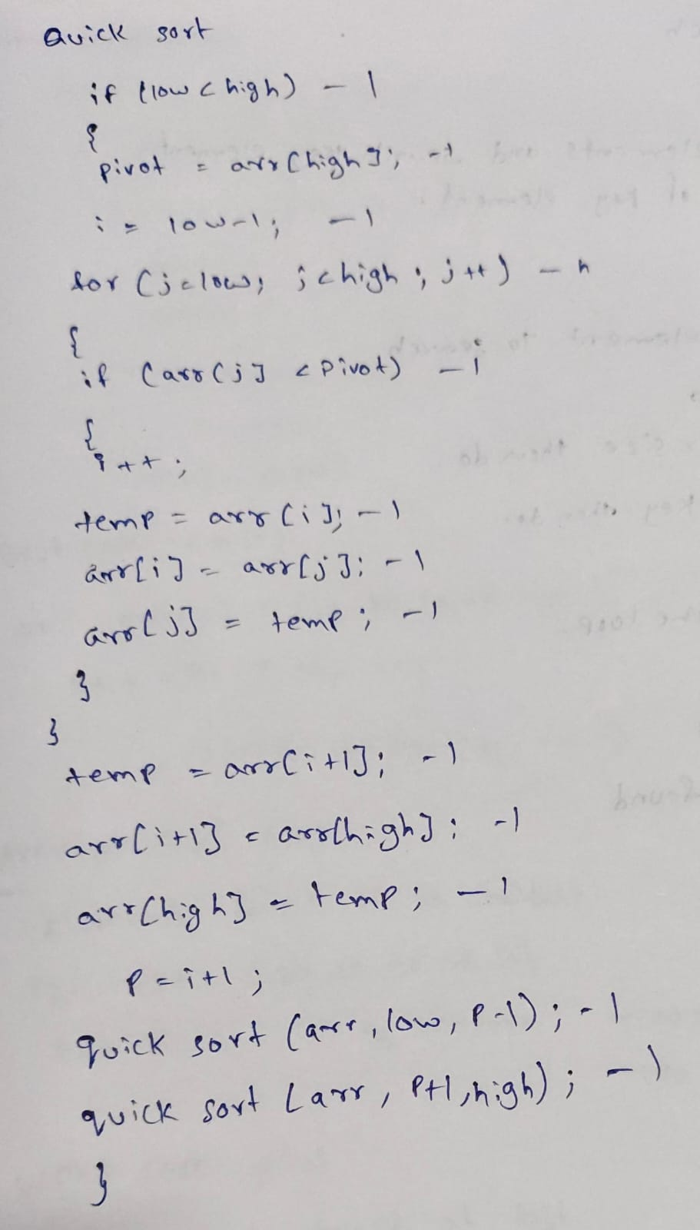

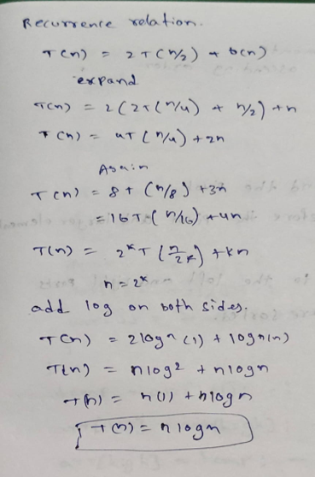

average case : Pivot usually creates reasonably balanced partitions

worst case : Pivot is always the smallest or largest element
